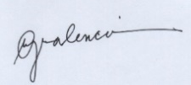
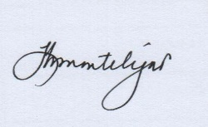


11

General Mathematics
Activity Sheets
Quarter 2 – MELC 1

Illustrating Simple and Compound Interest


REGION VI – WESTERN VISAYAS

General Mathematics 11

Activity Sheet No. 01
First Edition, 2020

Published in the Philippines
By the Department of Education Region 6 – Western Visayas

Republic Act 8293, section 176 states that: No copyright shall subsist in any work of the Government of the Philippines. However, prior approval of the government agency or office wherein the work is created shall be necessary for exploitation of such work for profit. Such agency or office may, among other things, impose as a condition the payment of royalties.

This Learning Activity Sheet is developed by DepEd Region 6 – Western Visayas.

ALL RIGHTS RESERVED. No part of this learning resource may be reproduced or transmitted in any form or by any means electronic or mechanical without written permission from the DepEd Regional Office 6 – Western Visayas.
Development Team of General Mathematics Activity Sheet Writer: Rutchel J. Ngipen
Illustrator: Rutchel J. Ngipen

Layout Artist: Rutchel J. Ngipen

Schools Division Quality Assurance Team:
Ligaya H. Montelijao, EPS-Mathematics
Leila G. Valencia, EPS-LR
Jezereel Grace G. Tiron
Bernie P. Alcedo
Division of Iloilo City Management Team:
Ma. Luz M. De los Reyes, SDS
Ernesto F. Servillon Jr., ASDS
Arlo L. Villalva, CID Chief
Dr. Jerry M. Lego, SGOD Chief
Leila G. Valencia, EPS-LR
Ligaya H. Montelijao, EPS-Mathematics
Regional Management Team
Ma. Gemma M. Ledesma, Dr. Josilyn S. Solana,
Dr. Elena P. Gonzaga, Mr. Donald T. Genine, Mr. Adonis Mosquera
Mrs. Rhodalyn Delcano

Introductory Message

Welcome to General Mathematics 11!

The Learning Activity Sheet is a product of the collaborative efforts of the Schools Division of Iloilo City and DepEd Regional Office VI - Western Visayas through the Curriculum and Learning Management Division (CLMD). This is developed to guide the learning facilitators (teachers, parents and responsible adults) in helping the learners meet the standards set by the K to 12 Basic Education Curriculum.

The Learning Activity Sheet is self-directed instructional materials aimed to guide the learners in accomplishing activities at their own pace and time using the contextualized resources in the community. This will also assist the learners in acquiring the lifelong learning skills, knowledge and attitudes for productivity and employment.




For learning facilitator:

The General Mathematics Activity Sheet will help you facilitate the teaching-learning activities specified in each Most Essential Learning Competency (MELC) with minimal or no face-to-face encounter between you and learner. This will be made available to the learners with the references/links to ease the independent learning.




For the learner:

The General Mathematics Activity Sheet is developed to help you continue learning even if you are not in school. This learning material provides you with meaningful and engaging activities for independent learning. Being an active learner, carefully read and understand the instructions then perform the activities and answer the assessments. This will be returned to your facilitator on the agreed schedule.

Learning Activity Sheets (LAS) No. 1
Quarter 2, Week 1

Name of Learner: ___________________ Grade and Section: _________________
Date: _____________________________

GENERAL MATHEMATICS ACTIVITY SHEET
Illustrating Simple and Compound Interest

- Learning Competency with Code
Illustrates simple and compound interest. (M11GM-IIa-1)

- Background Information for Learners
“What are some ways to take care of hard-earned money?” You can buy things that you only need, save the money, invest it in business, or think of the future.
When money is deposited in a bank or invested on savings account, it commonly attracts interest; in similar way, a borrower must normally pay interest on money borrowed. We received interest when we let other people use our money and at the same time we pay interest when we use other people’s money.
There are two basic ways of calculating the amount of interest paid on money deposited: simple interest and compound interest.

Important Terminologies:
- Lender or creditor – person (or institution) who invests the money or makes the funds available.
- Borrower or debtor – person (or institution) who owes the money or avails of the funds from the lender.
- Origin or loan date – date on which the money is received by the borrower.
- Repayment date or maturity date – date on which the money borrowed or loan is to be completely repaid.
- Time or term (t) – amount of time the money is borrowed or invested; length of time between the origin and maturity dates.
- Principal (P) – amount of money borrowed or invested on the origin date.
- Rate (r) – annual rate, usually in percent, charged by the lender, or rate of increase of the investment.
- Interest (I) – amount paid or earned for the use of money.
- Simple Interest (I_{s}) – interest that is computed on the principal and then added to it.
- Compound Interest (I_{c}) – interest computed on the principal and also on the accumulated past interest.
- Maturity value or future value (F) – amount after t years; balance at the end of t years; amount received by the lender from the borrower on the maturity date.

Illustration of Simple and Compound Interest:

Example 1: Suppose you won ₱100,000 in raffle draw and you plan to invest it in 5 years. A cooperative group in your community offers you 3% simple interest rate annually. At the same time, the bank offers 3% compounded annually. Compare the gain of the two investments and decide what offer you will accept and why.

Solution:
Investment 1 (cooperative group): simple interest, with annual rate r
Time (t) | Principal (P) | Simple Interest |  | Amount after t years  (Maturity Value)
Time (t) | Principal (P) | Solution | Answer | Amount after t years  (Maturity Value)
1 | ₱100,000 | (₱100,000) (0.03) (1) | ₱3,000 | ₱100,000 + ₱3,000 = ₱103,000
2 | ₱100,000 | (₱100,000) (0.03) (2) | ₱6,000 | ₱100,000 + ₱6,000 = ₱106,000
3 | ₱100,000 | (₱100,000) (0.03) (3) | ₱9,000 | ₱100,000 + ₱9,000 = ₱109,000
4 | ₱100,000 | (₱100,000) (0.03) (4) | ₱12,000 | ₱100,000 + ₱12,000 = ₱112,000
5 | ₱100,000 | (₱100,000) (0.03) (5) | ₱15,000 | ₱100,000 + ₱15,000 = ₱115,000

Investment 2 (bank): compound interest, with annual rate r
Time (t) | Principal (P)  Amount at the start of year t | Compound Interest |  | Amount at the end of year t  (Maturity Value)
Time (t) | Principal (P)  Amount at the start of year t | Solution | Answer | Amount at the end of year t  (Maturity Value)
1 | ₱100,000 | (₱100,000) (0.03) (1) | ₱3,000 | ₱100,000 + ₱3,000 = ₱103,000
2 | ₱103,000 | (₱103,000) (0.03) (1) | ₱3,090 | ₱103,000 + ₱3,090 = ₱106,090
3 | ₱106,090 | (₱106,090) (0.03) (1) | ₱3,182.70 | ₱106,090 + ₱3,182.70 = ₱109,272.70
4 | ₱109,272.70 | (₱109,272.70) (0.03) (1) | ₱3,278.18 | ₱109,272.70+ ₱3,278.18 = ₱112,550.88
5 | ₱112,550.88 | (₱112,550.88) (0.03) (1) | ₱3,376.53 | ₱112,550.88+ ₱3,376.53 = ₱115,927.41

Amount of interest gained in the two investments after 5 years:
Investment 1 (Simple Interest): ₱115,000 - ₱100,000 = ₱15,000
Investment 2 (Compound Interest): ₱115,927.41 - ₱100,000 = ₱15,927.41
Now, which offer will you accept?

Example 2: Using the data in example 1, what is the trend or behavior of the maturity value of each interest after 5 years (refer to the graph)?
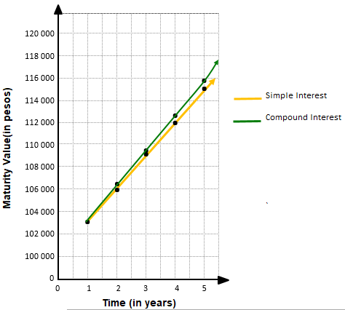
Solution:
The figure shows that
the trend of simple interest
is an increasing straight line
and increasing curve line for
the compound interest.

Note: Lines and curves are
graphs that can be
expressed in function
or equation form.

- Accompanying DepEd Textbook and Education Sites
https://www.coursehero.com/file/67466798/compound-interestpdf/
https://www.bigideasmath.com/protected/content/ipe/grade%208/10/g8_10_01.pdf
https://www.coursehero.com/file/23987306/Chp8-3Editionpdf/
General Mathematics Learner's Materials. Pasig City: Department of Education - Bureau of Learning Resources, 2016, pp 135-168
- Activity Proper
General Directions: In answering the exercises in the Learning Activity Sheet (LAS), please be reminded not to write anything here. All answers must be written in a separate sheet of paper. Read each problem carefully and answer it systematically. If solution is required, encircle your final answer.

Exercise 1: You deposit ₱50,000 in a savings account that earns 5% interest per year.
- Copy and complete the first table that shows the balance after 10 years with simple interest.
- Copy and complete the second table that shows the balance after 10 years with compound interest.
- Which type of interest gives the greater balance?

Simple Interest |  |  |  |  | Compound Interest
t | Principal | Interest | Balance at the End of t Years |  | t | Principal | Interest | Balance at the End of t Years
1 | ₱50,000 | ₱2,500 | ₱52,500 |  | 1 | ₱50,000 | ₱2,500 | ₱52,500
2 | ₱50,000 | ₱5,000 | ₱55,000 |  | 2 | ₱52,500 | ₱2,625 | ₱55,125
3 |  |  |  |  | 3
4 |  |  |  |  | 4
5 |  |  |  |  | 5
6 |  |  |  |  | 6
7 |  |  |  |  | 7
8 |  |  |  |  | 8
9 |  |  |  |  | 9
10 |  |  |  |  | 10
Guide Questions:
- How can you find the maturity value after t years or the balance at the end of year in an account that uses simple interest?
- How can you find the maturity value after t years or the balance at the end of year in an account that uses compound interest?

Exercise 2:
- Graph the end-year balances for each type of interest in Exercise 1.
- Which graph is linear? Explain your reasoning.
- For the linear graph, write a linear function that represents the balance after t years.

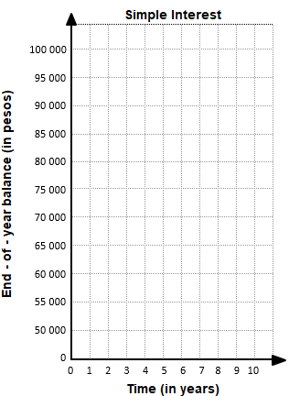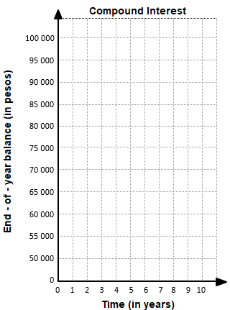

Guide Question:
- What are the different ways you can illustrate or represent simple and compound interest?
- What examples can you give that can represent simple or compound interest.

- Reflection
Instruction. Reflect on the following questions and write your response on your journal.
- What important idea/s have you learned from the learning activity sheet?
- What important value/s has been embedded to you by the lesson?
- In what way can you apply or use the lessons learned in your daily life as a student or in the future?

- Answer Key

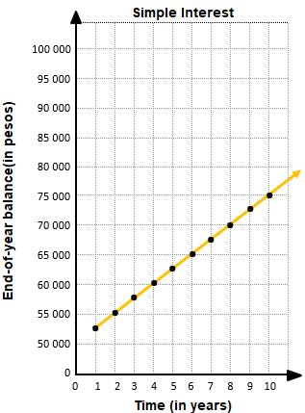
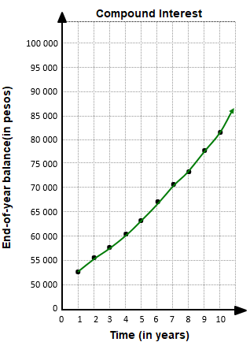

c. compound interest

Exercise 1 Exercise 2

Simple Interest
t | Principal | Interest | Balance at the End of t Years
1 | ₱50,000 | ₱2,500 | ₱52,500
2 | ₱50,000 | ₱5,000 | ₱55,000
3 | ₱50,000 | ₱7,500 | ₱57,500
4 | ₱50,000 | ₱10,000 | ₱60,000
5 | ₱50,000 | ₱12,500 | ₱62,500
6 | ₱50,000 | ₱15,000 | ₱65,000
7 | ₱50,000 | ₱17,500 | ₱67,500
8 | ₱50,000 | ₱20,000 | ₱70,000
9 | ₱50,000 | ₱22,500 | ₱72,500
10 | ₱50,000 | ₱25,000 | ₱75,000

Compound Interest
t | Principal | Interest | Balance at the End of t Years
1 | ₱50,000 | ₱2,500 | ₱52,500
2 | ₱52,500 | ₱2,625 | ₱55,125
3 | ₱55,125 | ₱2,756.25 | ₱57,881.25
4 | ₱57,881.25 | ₱2,894.06 | ₱60,775.31
5 | ₱60,775.31 | ₱3,038.77 | ₱63,814.08
6 | ₱63,814.08 | ₱3,190.70 | ₱67,004.78
7 | ₱67,004.78 | ₱3,350.24 | ₱70,355.02
8 | ₱70,355.02 | ₱3517.75 | ₱73,872.77
9 | ₱73,872.77 | ₱3,693.64 | ₱77,566.41
10 | ₱77,566.41 | ₱3,878.32 | ₱81,444.73

b. simple interest (reasons may vary)
c. B = 50,000 + 2500t

